Series Circuit

Subject:  Related Subjects: | Grade Level(s):  Length of Lesson: | Type: Inquiry / Design / Project  Keywords:

Lesson Overview
Use this section to describe at a high level what the lesson is. Should be no more than 3-4 lines.

Lesson Focus
What is the central question or phenomenon being investigated? What problem are they trying to solve?

Lesson Objective(s) | By the end of this lesson, students will…  - Learn the concepts of attraction, repulsion, friction, polarity, and charge.

Lesson Timing

5 minutes | Introduce the Lesson
30 minutes | ...

Materials | - 2 AA battery pack  - AA batteries  - Blue wire lights  - 4” x 4” piece of foam board  - Electrical tape  - Masking tape  - Scissors  - Wire strippers  - Brass fasteners  - Paper clip
Instructor Prep | - Step 1
Related Resources | - List related lessons/ppts etc available from USC or outside, trusted orgs

Lesson Plan

Introduction
When you have more than one electrical device in a circuit they can be connected in different ways, two of the simplest ways are series or parallel. A circuit that has all of its electrical devices connected in series is called a series circuit. Series means one after the other, so in a series circuit the electrical devices are connected on after the other. Parallel circuits are different in that all of the electrical devices in these circuits are parallel to each other.

Series circuits
With a series circuit the electrical components are connected so that there is only one path for the power to travel through the circuit. This means that if any of the components in the circuit is disconnected, none of them will turn on.

Concept activity:
Have three students come up to the front of the classroom, and form a line. Tell the class that these three students are “lights”, and you are the “power source”. Have the students stand so that they are “connected” in the line. This can be done by having them each put a hand on the shoulder of the student next to them (or their feet together if they don’t want to touch). Now, the “power source” should put their hand on the closest student. This is shown in the picture below. If there are two or more teachers/volunteers one can be the positive end of the “power source” and one can be negative end.

Questions to ask:
- Let’s say Light 2 lets go of Light 1. (See Figure 1 and 2 for reference. Also, it could be good for the students to hold signs to make it easy for the other students to see which is which.)
  - Will Light 1 still turn on?
  - Will Light 3 still turn on?
- Let’s say Light 3 lets go of Light 2.
  - Will Light 1 still turn on?
  - Will Light 2 still turn on?
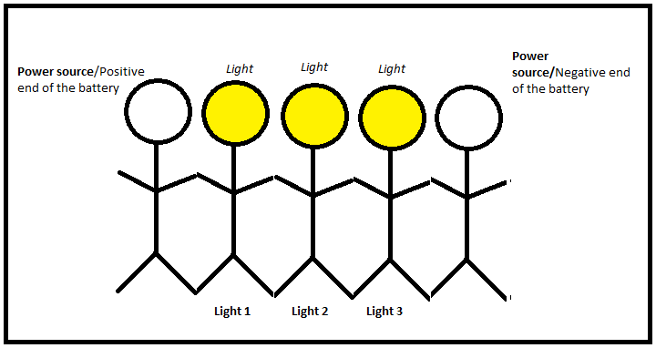
Because the lights are wired in series, if any of them are disconnected from the circuit none of them will turn on. There is only one path for the electricity to travel so if that path is broken it won’t reach any of the lights.
Figure 1. Lights 1-3 are connected – all are lit

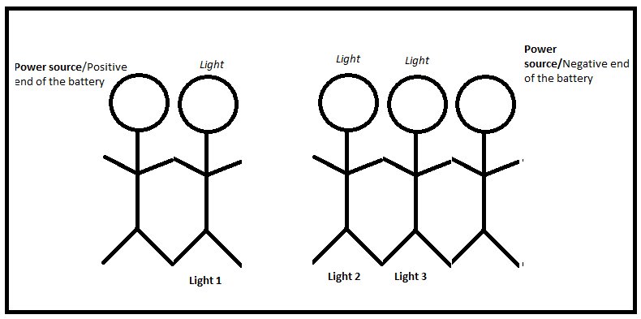

Figure 2. Lights 2 & 3 are disconnected from Light 1 – none are lit

Another important thing to note is that when electrical components are connected in series they split the power that is traveling through them. Because there is one path for the power to travel each of the components have to split the power that travels between them.
It is as if the positive power source gave Light 1 a piece of cake, and Light 1 took two bites and then gave the remaining cake to Light 2. Light 2 would also take two bites and then pass the remaining cake to Light 3. Light 3 would eat the last two bites of the cake. It’s the same way with real lights and batteries. The lights equally split the power of the battery. Thus, the more lights we add to the circuit the less power they each get.
Invite one more students to the front of the class room.
If we add one more light to our series circuit we all will still be splitting that one piece of cake. So now, because there is one more light in the circuit we each get one bite of cake instead of two bites of cake. So the “power source” would pass the cake to Light 1 and Light 1 would take a bite and pass the cake to Light 2 and so on.
What do you think would happen if we added one more light?
Invite one more students to the front of the class room.
If we add one more light to our circuit, do you think there will be enough cake to split between us? No, the more lights we add the less cake there will be to split between us. By the time we get to Light 5 there won’t be any more cake. If there is no cake left for Light 5 do you think Lights 1-4 will still turn on? No, all of the lights have to get cake (or power) in order for them to turn on. What is needed in order to have all of the lights turn on? More cake! (Pass the picture of the big cake down the line) If we have more power (or cake) there will be enough for all of the lights to share.
(End of concept activity)

Parallel circuits
With a parallel circuit the electrical components are connected so that there are multiple paths for the power to travel through the circuit. This means that if any of the components in the circuit is disconnected, the other ones can still turn on. To visualize how the components are set up, just think of parallel lines.


Figure 3. Parallel lines

Parallel lines never run into each other, they never connect. The same is true for parallel circuits, in these circuits the electrical devices are not connected to one another. They are each separately connected to the power source.
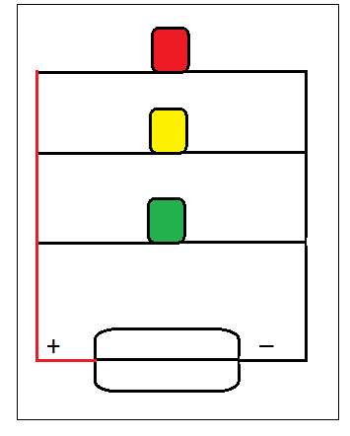

Figure 4. Lights connected in parallel

Another difference between parallel and series circuits is that electrical devices that are connected in parallel do not have to share the power between them. If we think back to our example with the cake before, two lights in parallel would not share one piece of cake. They would each get their own piece of cake.

Procedure
Students will build a series circuit using blue wire lights. (Important note: unlike LEDs, blue wire lights do not have polarity. Meaning they do not have a positive and negative end. You can connect either side to the positive or negative end of the battery.)

- Set up the blue wire lights so that they can fit on the board as shown in the figure below. This requires cutting and stripping the blue wire.
- Connect the blue wire lights so that they are in series.
- Create a brass fastener/paper clip switch
- Wire the switch, lights, and battery pack together.
- Connect a light in parallel
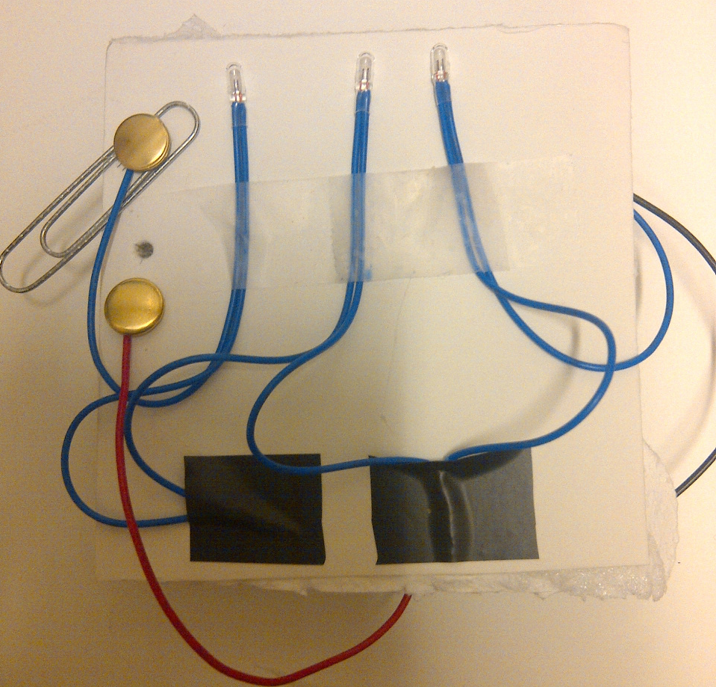

Figure 5. Series circuit

Wrap-up
End the lesson with some final discussions about what students designed/discovered. Connect their activity back to the focus question/problem, real world examples, and STEM careers.

Also include notes about any special cleanup considerations

Lesson Background for Teachers

Suggested Real-World STEM Connections
- List possible related Role Models in STEM (with details and links to more reading). Give suggestions for examples of scientists/engineers who are from underrepresented groups in STEM in related careers.
- List related real-world engineering problems and examples

Lesson Variations and Options
Include descriptions of alternative methods or ways to present things.

Explanation
Describe the background concepts and explanations behind the lesson. This can be more in depth than a teacher/instructor would actually share with students.

Key Concepts and Vocabulary
- Word 1: Grade Appropriate Definition
- Word 2: Grade Appropriate Definition

Safety Notes
- Safety instruction

